Advanced Transformations and Joins
Joins
Joins are used for combining data from multiple DataFrames based on one or more related columns. They are one of the most important operations in data engineering because business data is usually distributed across multiple datasets.
A join allows these datasets to be brought together to create a meaningful business dataset.

Joins In PySpark

DataFrame1 - Employee Data
emp_id | name | dept_id | salary
101 | John | 10 | 60000
102 | Mary | 20 | 55000
103 | David | 30 | 70000
104 | Lisa | 10 | 65000
105 | James | 50 | 80000

DataFrame2 – Department Data
dept_id | department
10 | IT
20 | HR
30 | Finance
40 | Marketing

The common column is dept_id.
A join can use dept_id to combine employee information with department information.
The result would be:
emp_id | name | dept_id | salary | department
101 | John | 10 | 60000 | IT
102 | Mary | 20 | 55000 | HR
103 | David | 30 | 70000 | Finance
104 | Lisa | 10 | 65000 | IT

The important point is that the join does not simply concatenate the DataFrames. It matches rows according to a specified relationship.

Join Condition
A join condition defines how records from two DataFrames should be matched.
The join conditions can involve:
- Single Column - Employee.dept_id = Department.dept_id
- Multiple Columns
Employee.department = Department.department
AND Employee.location = Department.location
- Equality Conditions
- Inequality Conditions
- Range Conditions
Employee.salary falls within a particular salary band.
- Compound Conditions using AND/OR
Types of Joins
- Inner Join
An Inner Join returns only the records that have a matching record in both DataFrames.
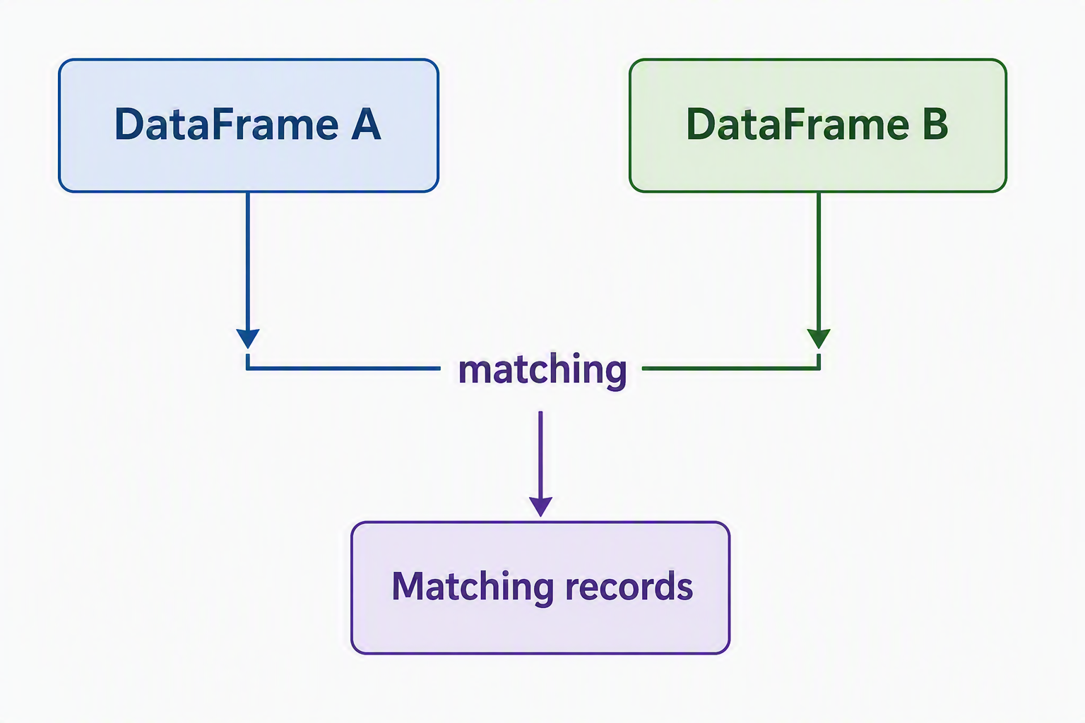
- Left Join
A Left Join returns all records from the left DataFrame along with matching records from the right DataFrame.
emp_id | name | dept_id | salary | department
101 | John | 10 | 60000 | IT
102 | Mary | 20 | 55000 | HR
103 | David | 30 | 70000 | Finance
104 | Lisa | 10 | 65000 | IT
105 | James | 50 | NULL | NULL

- Right Join
A Right Join is an exact opposite of left join. All records from the right DataFrame along with the matching records from the left DataFrame.

emp_id | name | dept_id | salary | department
101 | John | 10 | 60000 | IT
102 | Mary | 20 | 55000 | HR
103 | David | 30 | 70000 | Finance
104 | Lisa | 10 | 65000 | IT
NULL | NULL | NULL | NULL | Marketing

- Full Join
A Full Join, also, known as a Full Outer Join, preserves all records from both DataFrame. In a way, it represents union of Left Join & Right Join. Matching records are combined.
emp_id | name | dept_id | salary | department
101 | John | 10 | 60000 | IT
102 | Mary | 20 | 55000 | HR
103 | David | 30 | 70000 | Finance
104 | Lisa | 10 | 65000 | IT
105 | James | 50 | NULL | NULL
NULL | NULL | NULL | NULL | Marketing

- Cross Join
A Cross Join is fundamentally different from the other joins. Instead of matching rows based on a key, it produces every possible combination of rows from the two DataFrames.
DataFrame1 – Products
Product
Laptop
Tablet
Mobile

DataFrame2 – Location
Location
Mumbai
Delhi

Cross Join result:
Product | Location
Laptop | Mumbai
Laptop | Delhi
Tablet | Mumbai
Tablet | Delhi
Mobile | Mumbai
Mobile | Delhi

Every product is paired with every location.
Join Comparison
Join Type | Left Records | Right Records | Matching Records | Unmatched Left | Unmatched Right
Inner | Only matching | Only matching | Yes | Removed | Removed
Left | All | Matching | Yes | Preserved | —
Right | Matching | All | Yes | — | Preserved
Full | All | All | Yes | Preserved | Preserved
Cross | All combinations | All combinations | Not required | N/A | N/A

Join Cardinality
Cardinality describes how many records can match between the two datasets.
- One-To-One
- One-To-Many
- Many-To-One
- Many-To-Many
Advanced Functions
Aggregations
- rollup()
- cube()
Demo
Retail Sales Analytics
Tasks:
- Sales ranking
- Running totals
- Product performance analysis
Performance Optimization and Tuning
Performance optimization is PySpark is the process of making Spark applications execute faster, use cluster resources efficiently, reduce unnecessary movement of data, and process large datasets reliably.
A PySpark application may work perfectly on a small dataset but become slow when the data grows from gigabytes to terabytes. Performance tuning becomes important because Spark operates in a distributed environment, where the data is divided across multiple machines or excecutors.
Optimization Techniques
- Cache and Persist
- Partitioning
- Broadcast Joins
Spark UI
- Jobs Tab
- Stages Tab
- Executors Tab
Understanding Spark Performance
Before discussing optimization, it is important to understand how Spark actually executes a PySpark application.

A PySpark Application conceptual flow:
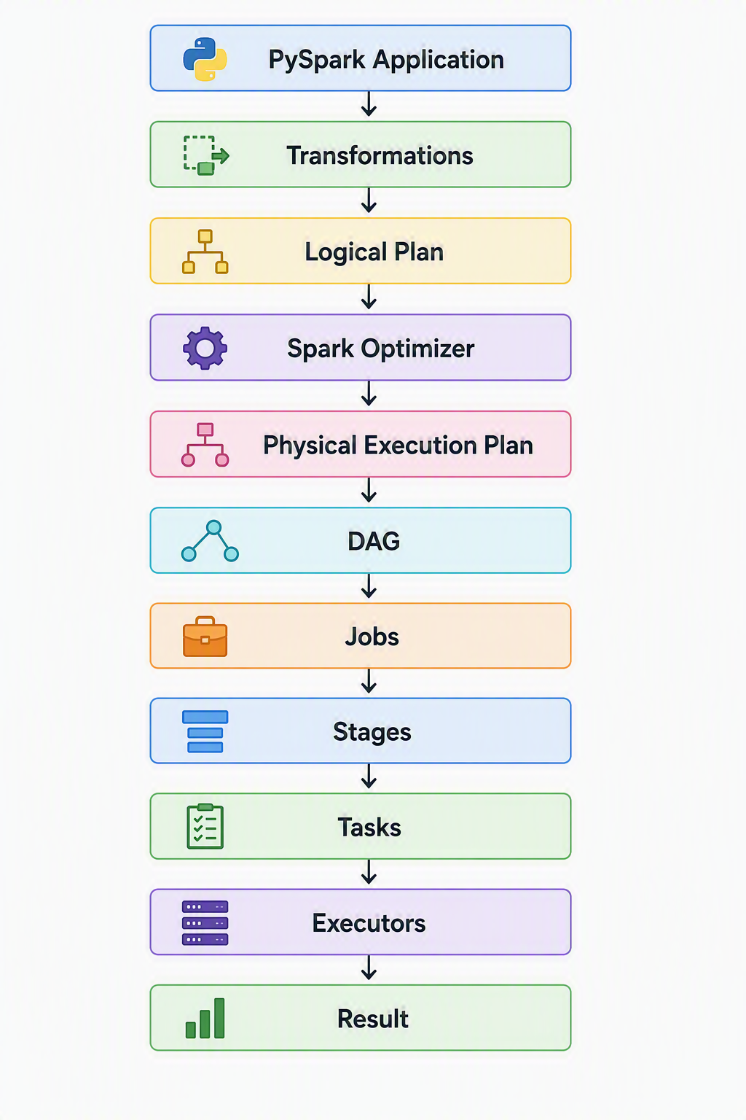
The Developers role is to describe what should be done, while Spark determines how to execute it efficiently.
Spark Performance Concepts
- Lazy Evaluation
Lazy Evaluation means PySpark does not immediately execute transformations when they are definition. Instead, Spark builds an execution plan & waits until an action requires a result. This allows Spark to analyze the complete chain of operations & optimize execution.
- Transformations vs Actions
Aspect | Transformations | Actions
Definition | Describe how a DataFrame or Dataset should be changed. | Request an actual result from Spark.
Purpose | Build the data processing logic. | Trigger the execution of the processing logic.
Output | Generally produces another DataFrame or Dataset. | Produces a result, writes data, or returns information to the driver.
Execution | Evaluated lazily and not executed immediately. | Triggers Spark to execute the required computation.
Impact on DAG | Adds operations to the logical execution plan (DAG). | Causes Spark to execute the DAG.
Examples | Filtering records, Selecting columns, Adding columns, Removing columns, Grouping data, Joining DataFrames, Sorting data, Aggregating data | Displaying records, Counting records, Collecting results, Writing data to storage, Calculating final outputs
Common PySpark Methods | filter(), select(), withColumn(), drop(), groupBy(), join(), orderBy(), agg() | show(), count(), collect(), write(), save()

- DAG Execution
DAG (Directed Acyclic Graph) represents the sequence & dependency relationships between operations. It describes how the input data must flow through transformations to produce the final result.
- Catalyst Optimizer
It analyzes the logical plan & applies optimization rules before generating a physical execution plan.
- Stages and Tasks
Stages
A stage is a group of tasks that can be executed together without requiring a major redistribution of data.
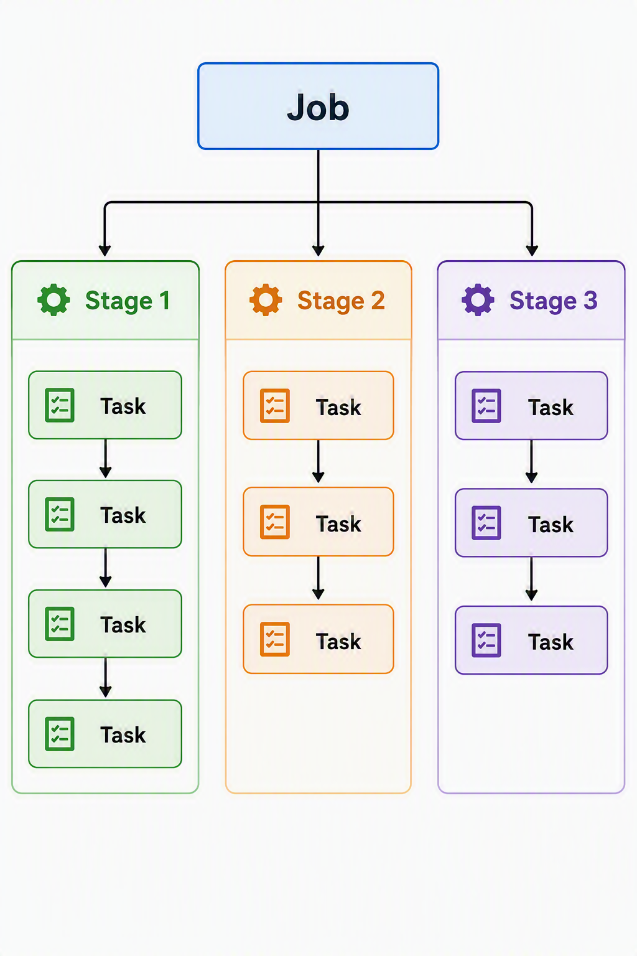
What creates a Stage Boundary?
Major reason is Shuffle which could be triggered by the operations:
  - Large Joins
  - Grouping
  - Aggregations
  - Sorting
  - Repartitioning
Task
Task is the smallest unit of work that Spark schedules for execution.
Demo
Performance comparison exercises:
- Before optimization
- After optimization
Structured Streaming with PySpark
Structured Streaming is the streaming engine in Spart that allows PySpark application to process continuously arriving data using the same DataFrame & SQL concepts used for batch processing.
Streaming Fundamentals
- Batch vs Streaming
What is streaming?
In conventional batch processing, the data is collected first & processed later.
In Streaming, the data is processed continuously upon its arrival.
Feature | Batch Processing | Streaming
Data | Bounded | Unbounded
Processing | Periodic | Continuous
Execution | Starts and finishes | Continuously running
Latency | Minutes/hours/days | Seconds/milliseconds depending on design
Example | Daily sales report | Live sales dashboard
Input | Files, tables | Kafka, files, sockets, etc.
Result | Finite output | Continuously updated output
Typical use | Historical analysis | Real-time analytics

- Structured Streaming Architecture
Main components
- Source
- Streaming DataFrame
- Transformations
- Query Execution
- State Management wherever required
- Sink
- Checkpointing
Streaming Sources
- File Source
- Kafka Introduction
- Socket Streams
Demo
Real-time Log Analysis
Tasks:
- Read streaming data
- Process events
- Generate metrics dashboard

